This documentation will help you to download the images from a website called Unsplash where can download the images.  
  
but to download that I used python and API key which is given by that website.

STEP-1

You need to make a developer account in that website..  
link -><https://unsplash.com/developers>

1. Register as developer

1. Then after click on **“Your apps”**

1. Click on “New application”

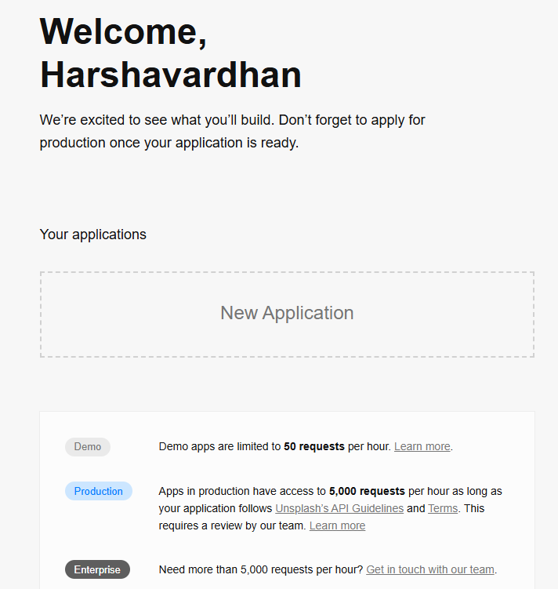

1. Agree all those terms and conditions, click on “Accept Terms”
2. Next give you application name and description. Just give any name for both application and description,

I gave “I need images for my gf” 😂😂

1. Then after ….here comes main part..  
   they will send you the verification mail..  
   open it and accept it..  
   and …close all those tabs..

* again click on this link -><https://unsplash.com/developers>
* login using email and password
* and do the same process from 3rd point above
* after that if you scroll down you can see something like this..  
  A screenshot of a computer

  AI-generated content may be incorrect.  
    
  you will use your access key..(don’t use this use yours 😑😑)

|  |  |
| --- | --- |
| Folder structure for the images  ## 🌐 Countries Used  - 🇮🇳 India  - 🇺🇸 USA  - 🇯🇵 Japan  - 🇹🇭 Thailand (labeled as `Thai`)  - 🇮🇹 Italy | ## 🏙️ Topics / Subfolders Used  Each country contains the following topics:  - `houses`  - `streets`  - `temples`  - `shops`  - `church`  - `mosques` |

so this access key is used to get the images..  
  
**now I will give you code here**

The folder structer that you are seeing above will be created directly my os lib using python on the code itself..so what you need to do is ..

* crete new folder and open in vs code
* create myenv..using this command in termial python -m venv myenv
* then after install these

->pip install requests

Then you copy paste code by creating new py file inside that folder

CODE

import os

import requests

# ✅ Your Unsplash Access Key

ACCESS_KEY = <YOUR _ACCESS_KEY HERE GIVE IN STRING FORMAT>

# 🌍 Countries and Topics

countries = {

    "India": ["Indian houses", "Indian streets", "Indian temples", "Indian shops", "Indian church", "Indian mosques"],

    "USA": ["USA houses", "USA streets", "USA temples", "USA shops", "USA church", "USA mosques"],

    "Japan": ["Japanese houses", "Japanese streets", "Japanese temples", "Japanese shops", "Japanese church", "Japanese mosques"],

    "Thai": ["Thai houses", "Thai streets", "Thai temples", "Thai shops", "Thai church", "Thai mosques"],

    "Italy": ["Italian houses", "Italian streets", "Italian temples", "Italian shops", "Italian church", "Italian mosques"]

}

# 🔧 Image Downloader

# count here and that function down both should be same.

def download_images(query, folder_path, count= <HOW MANY IMAGES YOU WANT PER SUB FOLDER>):

    url = "https://api.unsplash.com/search/photos"

    params = {

        "query": query,

        "per_page": count,

        "client_id": ACCESS_KEY

    }

    try:

        response = requests.get(url, params=params)

        response.raise_for_status()

        results = response.json().get("results", [])

    except Exception as e:

        print(f"❌ Error fetching '{query}': {e}")

        return

    for idx, result in enumerate(results):

        img_url = result["urls"]["regular"]

        try:

            img_data = requests.get(img_url).content

            filename = os.path.join(folder_path, f"{query.replace(' ', '_')}_{idx+1}.jpg")

            with open(filename, "wb") as f:

                f.write(img_data)

            print(f"✅ Saved: {filename}")

        except Exception as e:

            print(f"⚠️ Failed to download image: {img_url} — {e}")

# 🗂 Folder Creator and Runner

def run_downloader():

    base_folder = "images"

    os.makedirs(base_folder, exist_ok=True)

    for country, topics in countries.items():

        country_folder = os.path.join(base_folder, country)

        os.makedirs(country_folder, exist_ok=True)

        for topic in topics:

            sub_folder = os.path.join(country_folder, topic)

            os.makedirs(sub_folder, exist_ok=True)

            print(f"\n📂 Fetching: {topic}")

            download_images(topic, sub_folder, count=<>HOW MANY IMAGES YOU WANT PER SUB FOLDER>)

# 🏁 Entry Point

if __name__ == "__main__":

    run_downloader()

**DEFINE YOUR COUNT FO IMAGES PER SUB FOLDER IN CODE AND GIE YOUR API KEY**